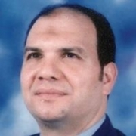
Curriculum Vitae

Personal Data
Name:Wagdy Ibrahim Ahamd Ali El-Dougdoug
Birth:8/09/64, Benha, Egypt.
Nationality:Egyptian
Address: Dept. of Chemistry , Benha University , New Benha, Qaliubiya Egypt.
Phone: (W) 0020133222981;Mob: 01002842538 (H)0020133194068
FAX: 002-013-3222578
E-mail:wagdi.ali@fsc bu.edu.eg
eldougdoug@yahoo.com
eldougdoug1@gmail.com
Education:-

